Exam 4 Review
Immunology
- What can weaken the immune system?

- What cells are associated with the immune system?

- How does the major histocompatibility complex work?

- What are the types of immunity?

- Give examples of the 1st, 2nd , and 3rd lines of defense.

- What are the four signs of inflammation? (Bonus: What are their Latin names?)

- Explain how antibodies work.

- True or False: Effector cells do NOT directly fight infections

- What do memory cells and effector cells do after B cell activation and proliferation of mature B cells occurs?

- What are the different types of T cells and how do they assist in an immune response?

- What is the hygiene hypothesis? What cells work with the allergen response in the body?

- Why is homeostasis so important?

- What are the different immunoglobulins and what do they do?

- What is a pro-inflammatory cytokine?

Renal System
- What are the functions of the renal system?

- What organs/structures are associated with the renal system?

- What are the functions of the kidneys?

- What are the 3 critical steps performed by the kidneys?

- What hormone controls fluid balance? Where is it secreted from?

- Blood, lymph, and nerve supply enters and exits the kidney at the ___________.

- The nephron is the _________________________________________. What does the nephron produce?

- What does the glomerulus do?

- What does the proximal convoluted tubule do?

- What do the descending and ascending Loops of Henle do?

- What does the distal convoluted tubule do?

- What do the collecting ducts do?

- What species have unilobar kidneys?

- What species have multilobar kidneys?

- What is the glomerular filtration rate?

- What are the characteristics of urine?

Endocrine System
- What are the primary functions of the endocrine system?

- The two components of the endocrine system are __________________ and _______________________. Endocrine glands release ___________ that circulate throughout the __________ to specific ______ causing a _______________ response. Endocrine glands are ________. They release products directly into the ________________. Imbalances in the endocrine system can ____________ function and cause ____________. The body uses positive and negative feedback loops to restore ________________ by turning on/off the production of ______________. Define and give an example of each type of feedback loop.

- Hormones are also known as...
- What are the three classes of hormones?

- Hormones are ___________ chains. They have a ___________________ relationship with their receptors.

- There are 3 modes of hormone transmission. What are they? How far does each one have to travel?

- What is half-life in reference to hormones?

- Hormones have two classes of biochemical structures.
  - ____________ hormones (_______)
    - Cholesterol-based (hydro_________)
    - Faster response due to _______________________ into cells
    - _________ half-life
    - Examples
      - Sex steroids:

  - ____________ hormones (_________)
    - __________________ derived (hydro________)
    - Bind to __________ on the outside of a cell. Then they utilize a 2nd messenger pathway which kicks off a ___________________ inside of the cell.
    - _________ half-life
    - Examples

- The ___________________ serves as the interface between the ____________ and endocrine systems. The three hormones associated with it are _____________ (nervous system related), __________________________, and _____________________. ________________ hormones stimulate other _______________ to be _______________.

- The pituitary gland is split into the _________ and ___________ pituitary glands. What hormones are associated with each part?

- How does chronic stress affect an animal in relation to hormones and body function?

- The thyroid gland’s function is _______________. It helps to regulate __________ use and _____ generation. It secretes both peptide-based and amine-based hormones. What are examples of each type?

- The parathyroid gland has both internal and external glands. The parathyroid gland releases ______________________________. What does this hormone do?

- The ___________ glands sit on top of the kidneys. What hormones are released from the cortex and what do they do? Which hormones are released by the medulla and what part of the nervous system do they control?

- Hormones work together to maintain _________________.
- The ____________ as sex dependent structures that produce hormones which affect the tissues known as ___________________. The gonads are the primary producers of _______________ which affect sex _________________. What are the male and female gonads and what hormones do they produce?

- The ______________ is both an endocrine and exocrine gland. It produces three types of hormones. What are they and what do they do?

- Explain how blood glucose is regulated.

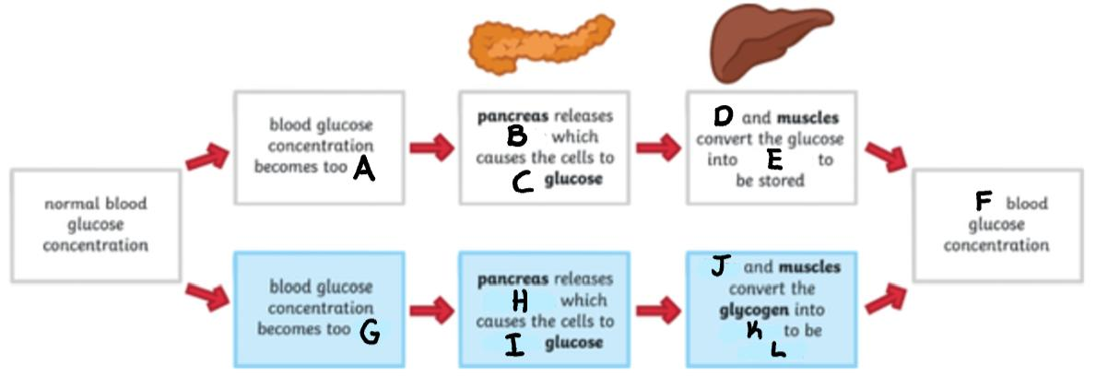
- Common endocrine disorders
  - ____________ à Insulin
  - Cushing’s Disease à _________________
  - ____________ à Thyroid
Digestive System
- Digestion is the ____________________. What is the digestive system’s function?

- The buccal cavity is the _________.
- List the organs (in order) that are found in the digestive system.

- Non-ruminants are ___________________. Pseudoruminants are ____________________________. Ruminants have a ___________________. Give examples of animals for each one.

- What do microbes do and what do they produce?

- Why is microbial fermentation important for ruminants?

- There are four sections of the ruminant’s stomach. What are they (in order) and what do they look/feel like?

- Define:
  - Nutrition
  - Nutrient
  - Essential Nutrient
  - Digestion
  - Absorption
  - Metabolism
    - Catabolism
    - Anabolism

- What are the cells in the stomach and what do they secrete?

- What are the four digestive enzymes and what do they digest?

- _____________ muscles in the digestive tract cause wave-like movements called __________________ contractions.
- What are the hormones in the digestive tract and what do they control?

- What is the brush border and what is its purpose?

- What are the major classes of nutrients?

Reproductive Systems
- Define:
  - Fertility:
  - Pregnancy:
  - Parturition:
  - Lactation:
  - Dystocia:
  - Estrous:
  - Estrus:
  - Diestrus:
  - Anestrous:
  - Standing Heat:
- There are 7 parts of the female repro tract that we learned about. What are they and what do they do?

- The ______________________ physically supports the ___________________ tract, in females, from the dorsal body wall. It is extremely ________ but strong. There are three parts. What are they and what do they attach to?

- Two hormones affecting how often and when estrous cycles occur in seasonal breeders are ___________ & ____________________. Give an example of monestrous, polyestrous, seasonal polyestrous, and induced ovulators.

- The uterus has ____ layers. What are they and what is associated with each one?

- __________________________ is the development of a new, mature egg. What hormones are associated with this and what are the 5 hormones involved and what do they do?

- __________________________ is the development of sperm cells. It occurs in the _______________________________. The maturation of sperm cells occurs in the _____________________. ____________ cells are called “nurse” cells because they provide necessary _________________ for development of sperm.

- What is the pathway that sperm follow in the male repro tract?

- What does the spermatic cord do?

- What is the pampiniform plexus?

- What is the creamaster muscle?

- What is a cryptorchid? What are the two types?

- The ______________ are the “master organ” of the male reproductive system. It is the site of production of ________________________ and _______________________. Testosterone is a sex _________, it drives _______________________. ______________________ drives the production of testosterone.

- There are three ducts found in the male reproductive system. What are they and what do they do?

- The ___________________ sex glands are the _______________, ________________ ____________, and ____________________________ _____________. What is the function of the _________________ sex glands?

- The _____________________ are _____ and ____. Secretion is prompted by _______ from the hypothalamus acting on the anterior pituitary. What do the FSH and LH do in males and females?

- AI stands for ___________________________. What are the benefits of using AI instead of natural cover?

